Examen Java - D
Formulario original: https://docs.google.com/forms/d/e/1FAIpQLSdXsOBHRoBzgpPzfPvlAzri9hCls9YcJ296eJLLiYVxOUmRkA/viewform
Enlazado desde: Exámenes de apoyo/LINKS.docx
Preguntas y opciones extraídas del formulario público el 24-sep-2026 (solo lectura; no se respondió ni se envió). El formulario no expone la clave de respuestas, así que este documento no marca la opción correcta.
Pregunta 1 (opción única)
What is the result?
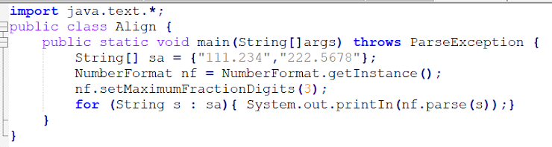
a) 111.234 222.567
b) An exception is thrown at runtime
c) 111.234 222.568
d) 111.234 222.5678

Pregunta 2 (opción única)
What is the result?
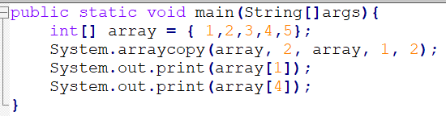
a) 14
b) 15
c) 34
d) 24
e) 35
f) 25

Pregunta 3 (opción única)
Which declaration initializes a boolean variable?
a) - boolean j = (1 < 5);
b) - boolean m = null;
c) - boolean h = 1;
d) - boolean k = 0;

Pregunta 4 (opción única)
Which two will compile, and can be run successfully usaing the following command? java Fred1 Hello walls.
a) abstract class Fred1 {public static void main(String[] args){System.out.println(args[2]);}}
b) class Fred 1{ public static void main(String args) { System.out.println(args[1]); } }
c) class Fred1 { public static void main(String[] args) { System.out.println(args[1]); }
d) class Fred1 { public static void main(String[] args) { System.out.println(args); } }

Pregunta 5 (opción única)
How many times is 2 printed?
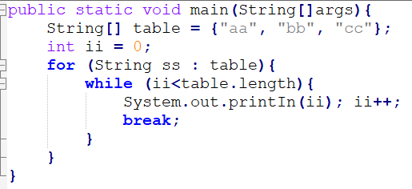
a) Thrice
b) It is not printed because compilation fails
c) Twice
d) Zero
e) Once

Pregunta 6 (selección múltiple)
Which five methods, inserted independently at line 5, will compile? (Choose five).
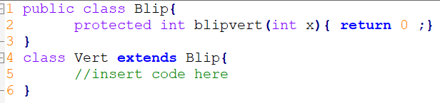
a) Protected long blipvert(long x) { return 0; }
b) Public int blipvert(int x) { return 0; }
c) Private int blipvert(long x) { return 0; }
d) Protected long blipvert(int x, int y) { return 0; }
e) Protected long blipvert(int x) { return 0; }
f) Protected int blipvert(long x) { return 0; }
g) Private int blipvert(int x) { return 0; }

Pregunta 7 (opción única)
Which two are valid instantiations and initializations of a multidimensional array?
a) array2D[0][0] = 1; array2D[0][1] = 2; array2D[1][0] = 3; array2D[1][1] = 4;
b) array3D[0][0] = array; array3D[0][1] = array; array3D[1][0] = array; array3D[0][1] =array;
c) int[][] array2D = {0, 1};
d) int[][][] array3D = {{0, 1}, {2, 3}, {4, 5}}; int[] array = {0, 1}; int[][][] array3D = newint[2][2][2];
e) int [][] array2D = {{0, 1, 2, 4}{5, 6}}; int[][] array2D = new int[2][2];

Pregunta 8 (opción única)
What is the result?
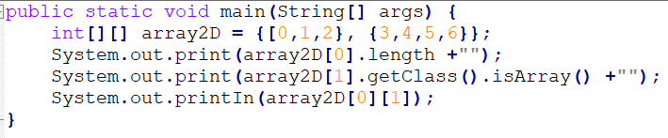
a) 3false3
b) 3true1
c) 3false1
d) 2false1
e) 2false3
f) 2true3
g) 2true1

Pregunta 9 (opción única)
In Java the difference between throws and throw Is:
a) Throws indicates the type of exception that the method does not handle andthrow an exception.
b) Throws throws an exception and throw indicates the type of exception that themethod.
c) Throws is used in methods and throw in constructors.

Pregunta 10 (opción única)
The standard API for accessing databases in Java is:
a) JPA/Hibernate
b) JDBC
c) ODBC

Pregunta 11 (opción única)
What changes will make this code compile?
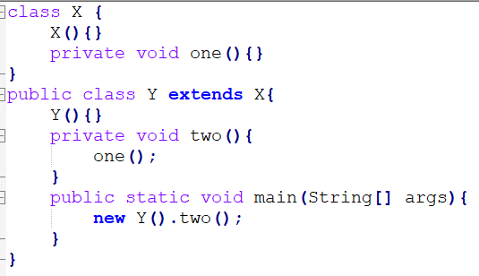
a) Adding the public modifier to the declaration of class X.
b) Assing the protected modifier to the X() constructor.
c) Changing the private modifier on the declaration of the one() method to protected.
d) Removing the private modifier from the two() method.
e) Removing the Y() constructor.

Pregunta 12 (opción única)
Which satement is true?
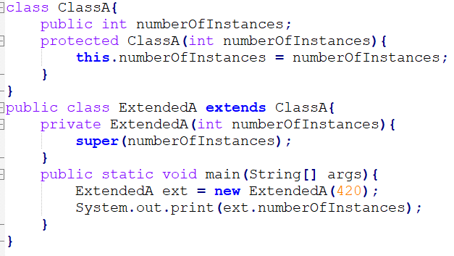
a) Constructors CANNOT use the protected modifier
b) Constructors CANNOT use the private modifier
c) An exception is thrown at runtime.
d) All constructors must be declared public.
e) 420 is the output.

Pregunta 13 (selección múltiple)
Which three are valid? (Choose three).
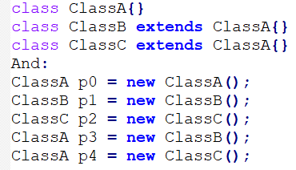
a) p1 = p2;
b) p2 = (ClassC)p4;
c) p2 = p4;
d) p1 = (ClassB)p3;
e) p0 = p1;
f) p2 = (ClassC)p1;

Pregunta 14 (opción única)
What is the result?
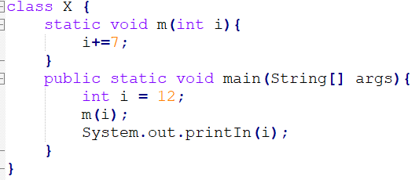
a) Compilation fails.
b) 12
c) 7
d) 19
e) An exception is thrown at run time.

Pregunta 15 (opción única)
What is the result?
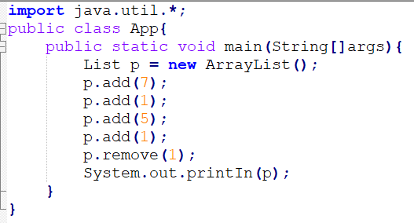
a) [ 7, 1]
b) [7, 1, 5, 1]
c) [7, 5, 1]
d) [7, 5]

Pregunta 16 (opción única)
What is the result?
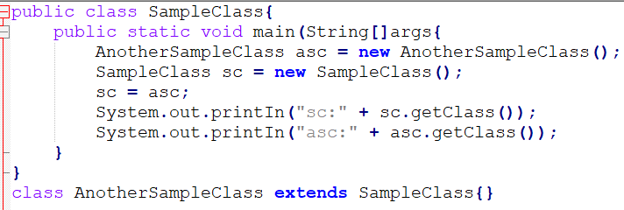
a) sc: class.Object asc: class.AnotherSampleClass
b) sc: class.AnotherSampleClass asc: class.SampleClass
c) sc: class.AnotherSampleClass asc: class.AnotherSampleClass
d) sc: class.SampleClass asc: class.AnotherSampleClass

Pregunta 17 (opción única)
What is the result?
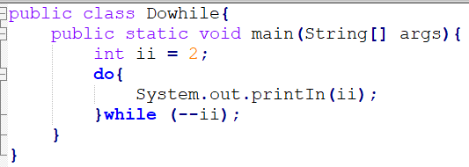
a) Compilation fails.
b) 2 1 2
c) 1 0
d) null.
e) An infinite loop.

Pregunta 18 (opción única)
What is the best way to test that the values of h1 and h2 are the same?
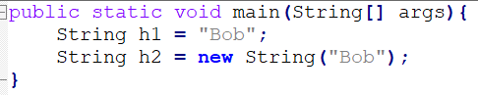
a) if (h1.equals(h2)).
b) if (h1 == h2).
c) if (h1.toString() == h2.toString()).
d) if (h1.same(h2)).

Pregunta 19 (opción única)
The pom.xml file is the configuration file For:
a) Maven.
b) Ant.
c) Gradle

Pregunta 20 (opción única)
The BUILDER pattern is used to:
a) Having several constructor methods in a class.
b) Simplify the creation of complex objects.
c) Implement the constructor of a class.

Pregunta 21 (opción única)
What is the result?
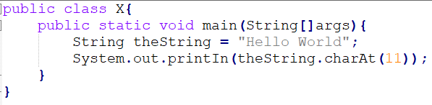
a) A StringIndexOutOfBoundsException is thrown at runtime.
b) There is no output.
c) A StringArrayIndexOutOfBoundsException is thrown at runtim.
d) d is output.
e) A NullPointException is thrown at runtime.
f) An ArrayIndexOutOfBoundsException is thrown at runtime.

Pregunta 22 (opción única)
What is the result?
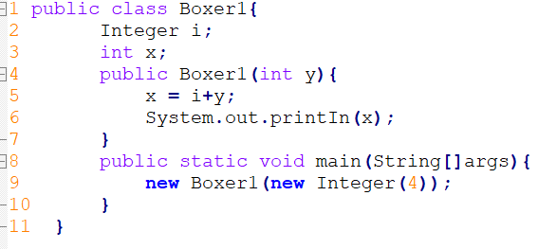
a) A NullPointerException occurs at runtime.
b) The value "4" is printed at the command line.
c) An IllegalStateException occurs at runtime.
d) Compilation fails because of an error in line 9.
e) Compilation fails because of an error in line 5.
f) A NumberFormatException occurs at runtime.

Pregunta 23 (selección múltiple)
Which three lines will compile and output "Right on!"?
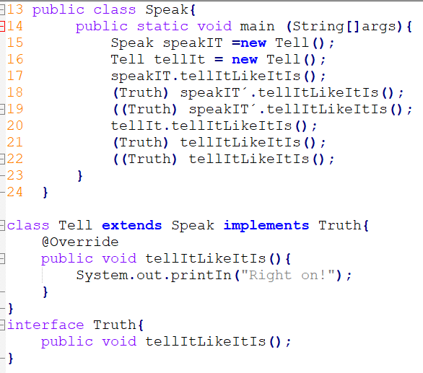
a) Line 22.
b) Line 17.
c) Line 20.
d) Line 21
e) Line 19.
f) Line 18.

Pregunta 24 (opción única)

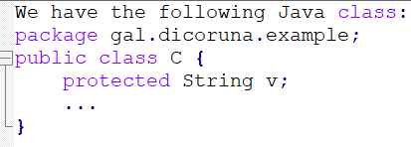
a) From the class, the package, subclasses.
b) Any site but only read if it is outside the package.
c) From the class, the package, subclasses and all sites.

